**IDX Equity Real Time Summary**

**Record type 0 : Trading Status**

Begin

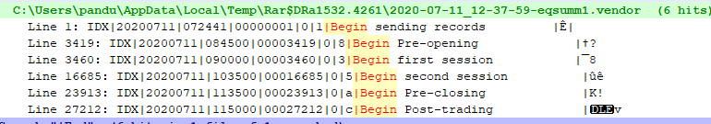

End

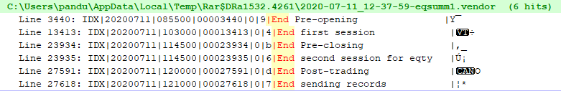

**Record type 3 : Stock Data**

IDX|20200711|072441|00000002|3|AALI |Astra Agro Lestari Tbk. |00000001550.00|00001924688333|00001924688333|--M-183PM2000012-------------- |00001924688333|˜é

**Record type 5 : Stocks Summary**

IDX|20200711|072442|00000816|5|AALI |NG |00000008200.00|00000000000.00|00000000000.00|00000000000.00|+00000.00|000000000000|0000000000000000|Ï1