**IDX Equity Real Time Indices**

**Record type 0 : Trading Status**

Begin

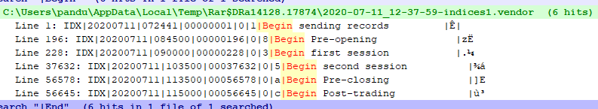

End

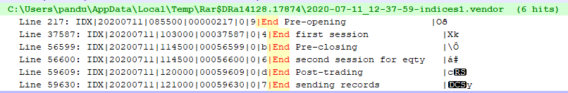

**Record type 6 : Indices**

IDX|20200711|072442|00000002|6|COMPOSITE |000005031.2560|000005031.2560|000005031.2560|000005031.2560|000005031.2560|ºÀ